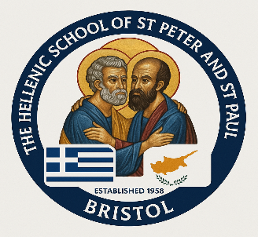

The Hellenic School of St Peter & St Paul
School Contribution Information

Important Note; the contributions go towards teachers, materials, stationary and other needs of the school, as funds to run the school are very limited. We wish to keep the donations as low as possible however we also need to cover the school costs.

Community Members

Parents and adult students are required to be community members for the below community member rates.

10 x Monthly Standing Order instalments the recommended option,

Please set this up yourself with your own bank and payments must start from 1st October 2025 and the end date; 1st July 2026 (inclusive) payable on 1st day of each month

School Bank Account Details -
School of the Greek Community of Bristol,

Sort code: 20-13-34
Account Number: 20781002
Your Reference: Student’s Surname

Primary School: 1 child = 10 x £30 2 children = 10 x £50 3 children = 10 x £70
Upper School: 1 child = 10 x £50 2 children = 10 x £90

If you have one child in Primary and one in Upper school then your Contribution will be £70

Adults: £150 per term

IMPORTANT NOTE:
If you are currently not a member then please complete the Community Charity Subscription Form - the minimum annual donation is £20 per adult student/Parent/Carer or £35 per Family.

Please complete the form https://www.greekcommunitybristol.org.uk/annual-subscription/

Non-Community Members Annual

1 child: £600 2 children: £900 3 children: £1500
Adults will be £250 per term

